

**FLY AWAY PLUS**

**DETAIL DESIGN DOCUMENT**

**Data Design**

**Project Code: FAP**

**Document Code: FAP_Data Design_v1.0_EN**

**Record of Change**

*A-Added M-Modified D-Deleted

|  |  |  |  |  |
| --- | --- | --- | --- | --- |
| Date | Item | A, M, D* | Change Description | Version |
| 2015/08/14 | Add new | A |  | V1.0 |

Table of Contents

1. Introduction 4

1.1. Purpose 4

1.2. Definitions, Acronyms and Abbreviations 4

1.3. References 4

1.4. Overview 4

2. Database 4

2.1. Entity Relationship Diagram 4

2.1.1. Entity Description 7

2.1.2. Relationship 7

2.2. Table Diagram 8

2.2.1. User Table 8

2.2.2. Comment Table 9

2.2.3. Conversation Table 9

2.2.4. Message Table 9

2.2.5. Notification Table 9

2.2.6. Post Table 10

2.2.7. Place Table 10

2.2.8. Photo Table 10

2.2.9. Video Table 11

2.2.10. Room Table 11

2.2.11. Report Post table 11

2.2.12. Report User table 12

# Introduction

## Purpose

Fly Away Plus data design document describes structure of database and file structure of system including internal file structure as well as interface file structure.

## References

|  |  |
| --- | --- |
| Document | Title |
| Class Design Document | FAP_Class Design_v1.0_EN |
| SRS |  |
| SAD |  |

## Overview

# Database

## Object Relationship Diagram

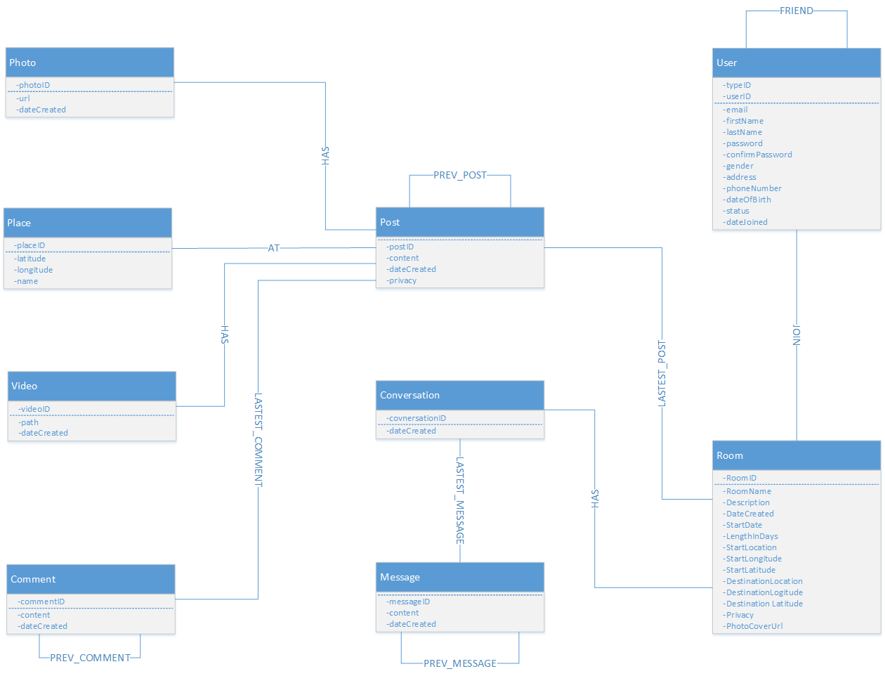

*User and Room Object Relationship Diagram*

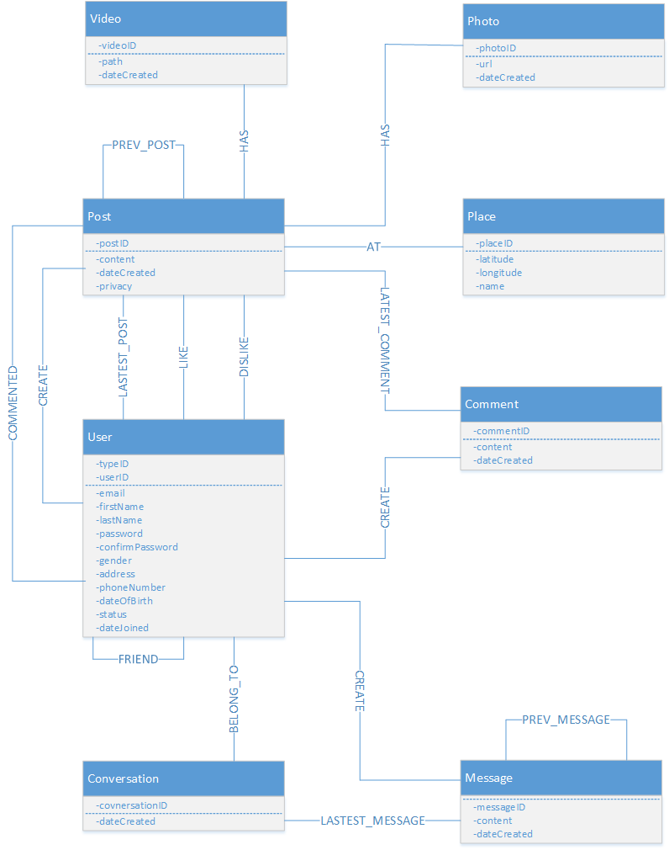

*User and Post Entity Relationship Diagram*

### Entity Description

|  |  |  |
| --- | --- | --- |
| No. | Entity | Description |
|  | User | User is all people who registered and using FAP |
|  | Post | A post which user published, contain content, videos, photos and places mention |
|  | Video | A video which user attached in a post while creating |
|  | Photo | Photo(s) which user attached in a post while creating |
|  | Place | A place which user must mention in a post while creating |
|  | Room | A group which user created, includes content, plan, members, photo, video and place mention |
|  | Message | Chat is message user sends or receives from others |
|  | Comment | A comment which user created, is placed in and associated to a post |

### Relationship

|  |  |  |  |  |
| --- | --- | --- | --- | --- |
| No. | Relation | Properties |  | Description |
|  | AT | None |  | A place that a post mentioned to |
|  | BELONG_TO | None |  | A conversation which was created by an user |
|  | COMMENTED | dateCreated  activityID |  | A post which user commented in  “dateCreated”: created time |
|  | CREATE | None |  | A post, message or comment which was created by an user |
|  | FRIEND | dateCreated  activityID |  | Two users are friend, exist in each other’s’ friend list  “dateCreated”: accepted friend request time |
|  | HAS | None |  | A post includes videos, photos  A room includes conversation |
|  | JOIN | None |  | User join a room  Type 0: Admin  Type 1: Member  Type 2: Request join |
|  | LASTEST_COMMENT | None |  | The latest comment of a post |
|  | LASTEST_MESSAGE | None |  | The lastest message of a conversation |
|  | LASTEST_POST | None |  | The lastest post which user was created  The lastest post which was created in room |
|  | PREV_COMMENT | None |  | Previous comment of a comment |
|  | PREV_MESSAGE | None |  | Previous message of a message |
|  | PREV_POST | None |  | Previous post of a post |
|  | VISITED | None |  | A place which user was visited |
|  | WISH | None |  | A place which was added int user wish list |

## Table Diagram

### User Table

|  |  |  |  |  |
| --- | --- | --- | --- | --- |
| No | Field Name | Type | Allow Null | Description |
|  | userID | int | No | User’s ID |
|  | typeID | int | No | User’s created type includes: normal, Facebook and Google+ resgistered |
|  | email | String | No | User’s email |
|  | firstName | String |  | User’s first name |
|  | lastName | String |  | User’s last name |
|  | password | String | No | User’s password |
|  | confirmPassword | String | No | User retypes password. Must be same as password. |
|  | address | String |  | User’s address |
|  | gender | String |  | User’s gender |
|  | phoneNumber | String |  | User’s phone number |
|  | dateOfBirth | String |  | User’s date of birth |
|  | status | String |  | User’s status |
|  | dateJoined | String | No | User’s joined date |
|  | avatar | String |  | User’s avatar |

### Comment Table

|  |  |  |  |  |
| --- | --- | --- | --- | --- |
| No | Field Name | Type | Allow Null | Description |
|  | commentID | int | No | Comment’s ID |
|  | content | String | No | Comment’s content |
|  | dataCreated | String | No | Comment’s created date |

### Conversation Table

|  |  |  |  |  |
| --- | --- | --- | --- | --- |
| No | Field Name | Type | Allow Null | Description |
|  | conversationID | String | No | Conversation’s ID |
|  | dataCreated | String | No | Conversation’s created date |

### Message Table

|  |  |  |  |  |
| --- | --- | --- | --- | --- |
| No | Field Name | Type | Allow Null | Description |
|  | messageID | int | No | Message’s ID |
|  | content | String | No | Message’s content |
|  | dateCreated | String | No | Message’s created date |

### Notification Table

|  |  |  |  |  |
| --- | --- | --- | --- | --- |
| No | Field Name | Type | Allow Null | Description |
|  | lastActivityID | int | No | Notification’s ID |
|  | activity | String | No | Notification’s activity |
|  | dateCreated | String | No | Notification’s created date |
|  | user | user | No | Activity’s owner |
|  | post | post | No | Activity’s location |

### Post Table

|  |  |  |  |  |
| --- | --- | --- | --- | --- |
| No | Field Name | Type | Allow Null | Description |
|  | postID | int | No | Post’s ID |
|  | content | String | No | Post’s content |
|  | dateCreated | String | No | Post’s created date |
|  | privacy | String | No | Post’s privacy |

### Place Table

|  |  |  |  |  |
| --- | --- | --- | --- | --- |
| No | Field Name | Type | Allow Null | Description |
|  | placeID | int | No | Place’s ID |
|  | longitude | decimal | No | Place’s longitude |
|  | latitude | decimal | No | Place’s latitude |
|  | name | String | No | Place’s name |

### Photo Table

|  |  |  |  |  |
| --- | --- | --- | --- | --- |
| No | Field Name | Type | Default | Description |
|  | photoID | int | No | Photo’s ID |
|  | url | String | No | Photo’s url |
|  | dateCreated | String | No | Photo’s created date |

### Video Table

|  |  |  |  |  |
| --- | --- | --- | --- | --- |
| No | Field Name | Type | Allow Null | Description |
|  | videoID | int | No | Video’s ID |
|  | path | String | No | Video’s url |
|  | dateCreated | String | No | Video’s created date |

### Room Table

|  |  |  |  |  |
| --- | --- | --- | --- | --- |
| No | Field Name | Type | Allow Null | Description |
|  | roomID | int | No | Room’s ID |
|  | roomName | String | No | Room’s name |
|  | dateCreated | String | No | Room’s created date |

### Report Post table

|  |  |  |  |  |
| --- | --- | --- | --- | --- |
| No | Field Name | Type | Allow Null | Description |
|  | reportID | int | No | Report’s ID |
|  | postID | int | No | Reported post’s ID |
|  | content | String | No | Report’s reason |
|  | userReportID | int | No | Report owner’s ID |
|  | userReportedID | int | No | Reported user’s ID |

### Report User table

|  |  |  |  |  |
| --- | --- | --- | --- | --- |
| No | Field Name | Type | Allow Null | Description |
|  | reportID | int | No | Report’s ID |
|  | content | String | No | Report’s reason |
|  | userReportID | int | No | Report owner’s ID |
|  | userReportedID | int | No | Reported user’s ID |